**AIM: Write a C program to implement Linked list operations**

**ALGORITHM:**

1. **Start**
2. **Define a structure (Node)** with two fields:
   * data (to store element)
   * next (to store address of next node)
3. **Initialize head = NULL** (empty list).
4. **Insertion Operation**
   * Create a new node.
   * Assign value to data.
   * If head == NULL, make head = newNode.
   * Else, traverse till the last node and link newNode at the end.
5. **Deletion Operation**
   * If head == NULL, print "List Empty".
   * Else, ask for the element to delete.
   * Traverse the list, keep track of previous node.
   * If found, unlink the node and free memory.
   * If not found, print "Element not found".
6. **Display Operation**
   * If head == NULL, print "List Empty".
   * Else, traverse and print each data until end.
7. **Repeat steps 4–6 using a menu until Exit is chosen.**
8. **Stop**

**CODE:**

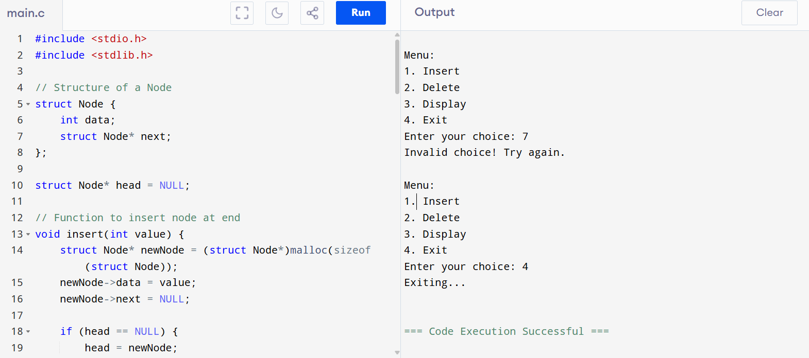

**OUTPUT:**

Menu:

1. Insert

2. Delete

3. Display

4. Exit

Enter your choice: 7

Invalid choice! Try again.

Menu:

1. Insert

2. Delete

3. Display

4. Exit

Enter your choice: 4